Contents

Purpose: 1

Collect permissions using an input csv file and exclude service accounts 1

Exclude Administrative Groups for better performance 2

Active Sync Devices functionality 2

Script notes 3

# Purpose:

Use the following guide when running the FTCMigrationPlanning powershell script. The main purpose of this script is to help identify associated delegates with users’ mailboxes. Cross premises permissions in Exchange hybrid environments are not supported, see here for more info: <https://technet.microsoft.com/en-us/library/jj200581(v=exchg.150).aspx>

This script will help identify associated delegates based on the following permissions:

* **Full Access** (DISABLED by default. To ENABLE, set $gatherfullaccess = $true within the script)
* **Send As**
* **GrantSendOnBehalfTo**
* **Calendar Folder** (DISABLED by default. To enable set $gathercalendar = $TRUE. Applicable to only Exch 2010+)

The script will help you output the above permissions for all mailboxes, run it through a batching algorithm to identify associated delegates, and recommend batches so that those users get migrated at the same time to avoid cross premise permission issues.

# Collect permissions using an input csv file and exclude service accounts

1. ***.\FTCMigrationPlanning.ps1 -UseImportCSV -RemoveServiceAccts***

*Note: The script will prompt you for a location to the user input csv file and the service accounts csv file.*

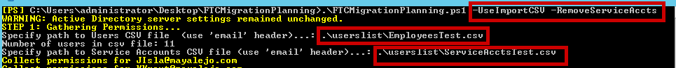

1. **Sample Input CSV File**

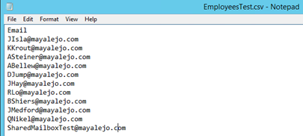

1. **Sample Exclude Remove Service Accounts File**

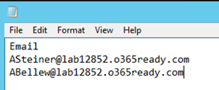

# Exclude Administrative Groups for better performance

The script excludes the following administrative groups to avoid having to enumerate these typically really large groups for each mailbox.

$Script:excludedGroups = "Exchange Organization Administrators","Organization Management","Exchange Servers"

If you have other highly privileged groups that you’re not interested in including in the batching logic, you can include them above.

# Active Sync Devices functionality

Registered active sync devices don’t get migrated. The script can be leveraged to help with this scenario by including the registered active sync devices in the migration schedule. After the migration, the script can be used which will check for migrated users and re-use the migration schedule to populate the registered active sync devices that the user had.

1. Include the registered active sync devices in the migration schedule

***.\FTCMigrationPlanning.ps1 -UseImportCSV -RemoveServiceAccts -ListActiveSyncDevices***

1. Migration schedule will look like this:

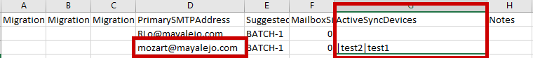

1. Submit the migration schedule to migrate those users. You’ll notice that users will not have the active sync devices migrated along with their mailbox

Before:

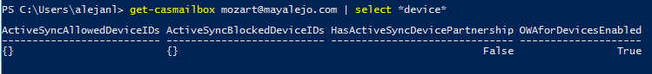

1. After the users in the migration schedule have been migrated. Add them back using the following switch:

***.\FTCMigrationPlanning.ps1 -AddActiveSyncDevices***

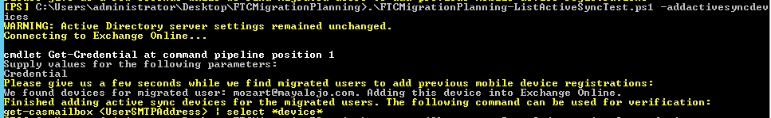

After:

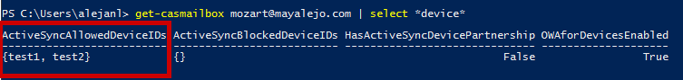

# Script notes

<#

.SYNOPSIS

Use this script to generate a migration schedule for mailboxes being migrated from on-premises environments to O365. The script will first collect all permissions, identify associated delegates, and generate a schedule in the format expected by the Microsoft FastTrack Center (FTC) team.

You can use the generated schedule to manipulate the mailboxes that you would like to migrate and share with the FTC team to submit for migration.

.DESCRIPTION

The sample scripts are not supported under any Microsoft standard support

program or service. The sample scripts are provided AS IS without warranty

of any kind. Microsoft further disclaims all implied warranties including,

without limitation, any implied warranties of merchantability or of fitness for

a particular purpose. The entire risk arising out of the use or performance of

the sample scripts and documentation remains with you. In no event shall

Microsoft, its authors, or anyone else involved in the creation, production, or

delivery of the scripts be liable for any damages whatsoever (including,

without limitation, damages for loss of business profits, business interruption,

loss of business information, or other pecuniary loss) arising out of the use

of or inability to use the sample scripts or documentation, even if Microsoft

has been advised of the possibility of such damages.

=========================================

Published date: 12/08/2016

+01252017: Corrected text in help from UserImportCSV to UseImportCSV

+12152016: Added check for Get-User when creating the migration schedule

+12082016: Change order of Remove Service Accounts prompt

+07282016: Added FullAccess permissions. Disabled by default.

+06272016: Update method to get calendar variable for different language

+06162016: Replaced preloaded variable for calendar with method to avoid issue with different language. Also updated Send As permissions to not include inherited permissions.

+03212016: Make calendar folder permissions disabled by default. To enable set the following setting to $true -> $gathercalendar = $TRUE

+03012016: Included ListActiveSyncDevices and AddActiveSyncDevices functionality. Included guidance in the read me file. Updated to .docx

+03012016: Removed FullAccess permissions, inserted Calendar-Folder permissions. Get Calendar Folder DISABLED BY DEFAULT.

+01272016: Added condition to exclude exchange administration default groups when enumerating group membership.

+01262016: Added condition to catch exception for ManagementObjectNotFoundException. Get-Recipient logs error when object doesn't have email, leading to confusion. This is expected.

+01222016: Updated scriptpath logic and $myinvocation to avoid intermittent split-path issues.

+01152016: Added logging to spot potential perf issues easier

+01132016: Comment out ListActiveSyncDevices and AddActiveSyncDevices, these are in development

+12172015: Add PageSize

+12032015: Added check for Invocation. If it fails save files to c: drive.

+11162015: Renamed OBC to FTC

+08112015: Group enumeration for both FullAccess and Send As Permissions

+08112015: Ability to list out ActiveSync Devices and to add to migrated mailboxes

Authors:

Alejandro Lopez - alejanl@microsoft.com

Sam Portelli - Sam.Portelli@microsoft.com

=========================================

.PARAMETER UseImportCSV

Use this parameter to specify a list of users to collect permissions for, rather than all mailboxes.

Make sure that the CSV file provided has a header titled "Email"

.PARAMETER RemoveServiceAccts

Use this parameter to specify a list of service accounts (or even public shared mailboxes that all users have permissions to) that you would like to exclude from permissions

Make sure that the CSV file provided has a header titled "Email"

.PARAMETER ListActiveSyncDevices

Use this parameter to include active sync devices allowed for the mailboxes in the on-premises environment. This will add a separate column to the migration schedule and list those devices in pipe-delimited format.

.PARAMETER AddActiveSyncDevices

Use this parameter to update migrated cloud mailboxes (using a schedule file of migrated mailboxes - must be schedule that includes the active sync devices, can be generated using the -ListActiveSyncDevices parameter) and add the active sync devices to the cloud mailboxes

.EXAMPLE

#Create Migration Schedule for ALL users - by default

.\ftcmigrationplanning.ps1

.EXAMPLE

#Create Migration Schedule for ALL users EXCEPT service accounts

.\ftcmigrationplanning.ps1 -RemoveServiceAccts

.EXAMPLE

#Create Migration Schedule for list of users

.\ftcmigrationplanning.ps1 -UseImportCSV

.EXAMPLE

#Create Migration Schedule for list of users except service accounts

.\ftcmigrationplanning.ps1 -UseImportCSV -RemoveServiceAccts

#>